EUFAR AISBL website - article template
Categories: News and Airborne Research Sorties
Krzysztof Dudek & Elisabeth Gérard, 17 December 2019 Version 1.2
__________________________________________________________________________________________________________________

This document shows where articles describing EUFAR activity can be found on the EUFAR AISBL website and provides an optimal article structure template to be sent to the EUFAR Office bureau@eufar.net for publication on the EUFAR website service.
- Article presentation on the EUFAR AISBL website
Home page (https://www.eufar.net)
There are two windows with an article announcement on the EUFAR AIBSL website Home page. The articles are presented in the News category and Airborne Research Stories category windows depending on article categorisation. All articles shown are in the same standardised form and contain the following elements: article title, excerpt and an illustrating picture. Figure 1 and Figure 2 presented below show how the News and Airborne Research Stories windows are displayed on the EUFAR website Home page. All article elements necessary for publishing are thoroughly defined hereafter.

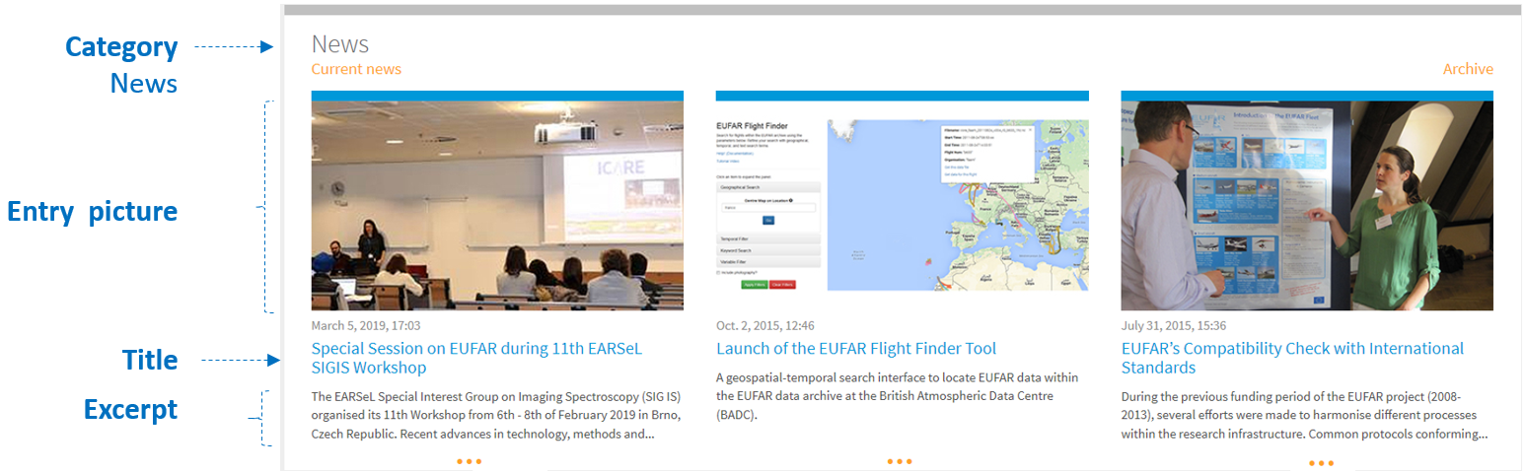
Figure 1: News window

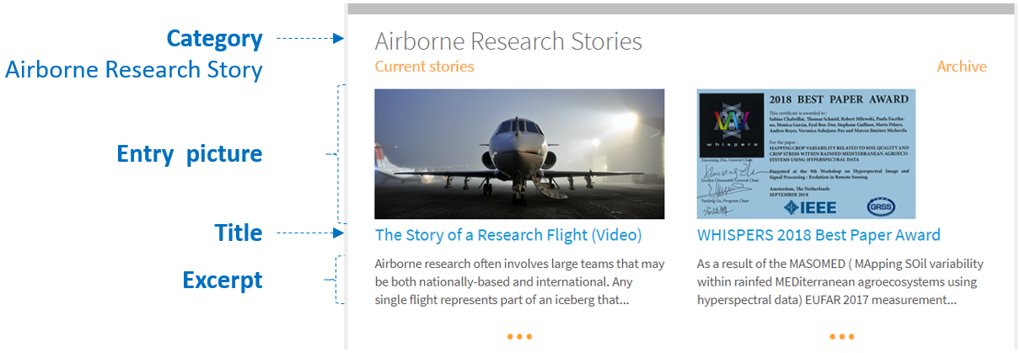
Figure 2: Airborne Research Stories window

Article dedicated page
Articles announced on the EUFAR AISBL website Home page can be opened on a separate, dedicated page. Any user can click on a link attached to an article title presented in blue or by clicking the “…” below an excerpt in the News section. The composition of the article essential elements on the dedicated web page is shown in Figure 3.

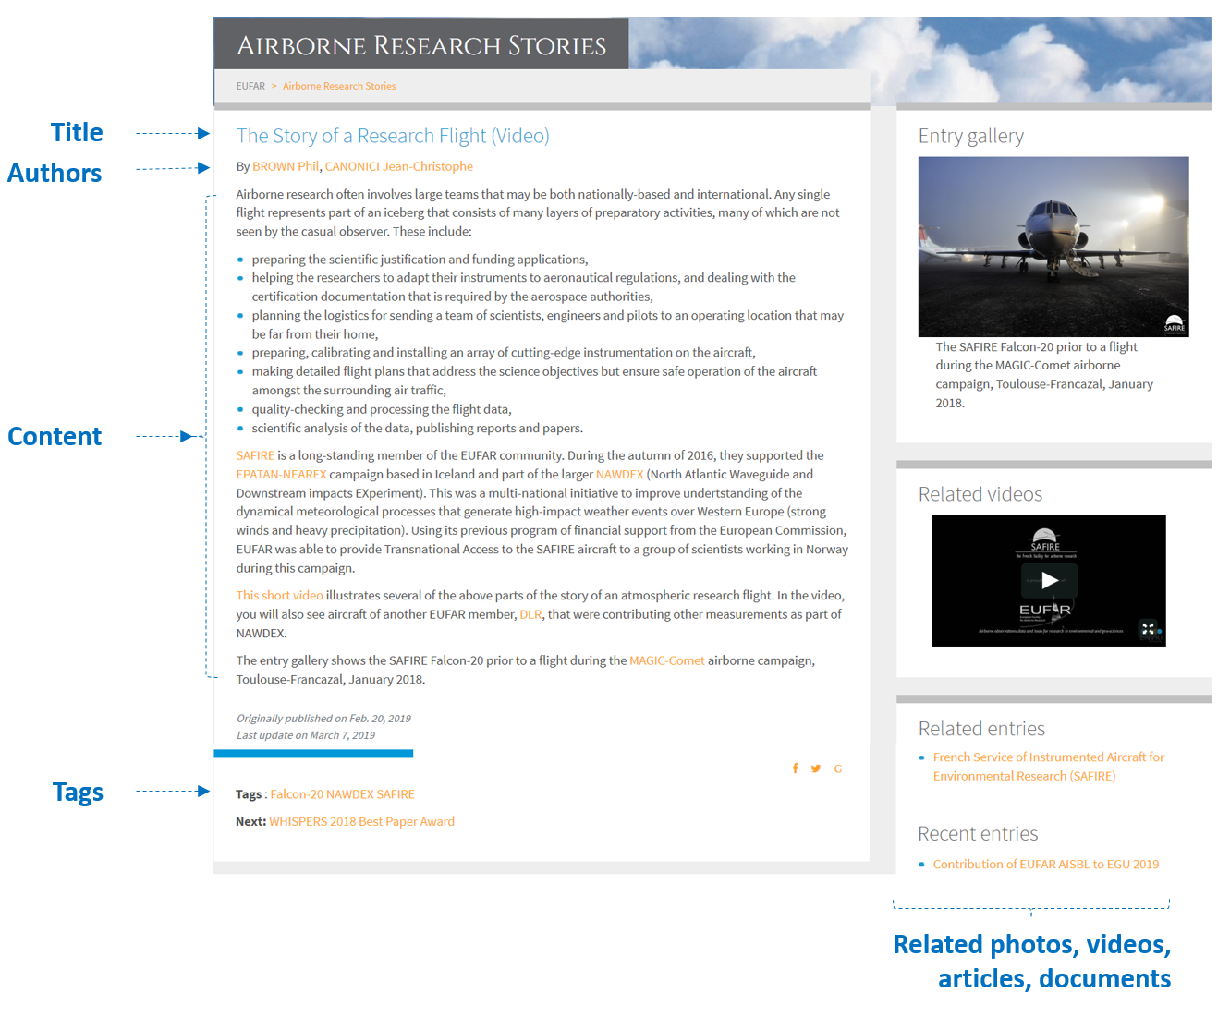
Figure 3: Article view

- Template
The article template shows what elements are necessary for a harmonised publication on the EUFAR AISBL website. All details described below should be completed and sent to EUFAR Office (bureau@eufar.net) along with photos, videos, documents, etc. and to be provided as separate files.
Category
News or Airborne Research Story (please make a suggestion by choosing one category)
Title
Max 255 characters
Authors

Authors must be registered as EUFAR website members
(Registration available following the link https://www.eufar.net/accounts/register/)
Excerpt

About 160 characters recommended (brief summary; beginning of content by default)
Content

Max 300-400 words for News / 2000 words for Airborne Research Story recommended
(tables, links and pictures can be included)
Entry picture

Resolution 400 x 225pixels recommended
Photo / video / document gallery
Sequence of photos / videos / documents (to be provided as separate files)

