EUFAR ESA Workshop on
Atmospheric Correction of
Remote Sensing Data

SUMMARY REPORT

26 – 28 October 2016
Harnack Haus, Berlin, Germany

Hosted by
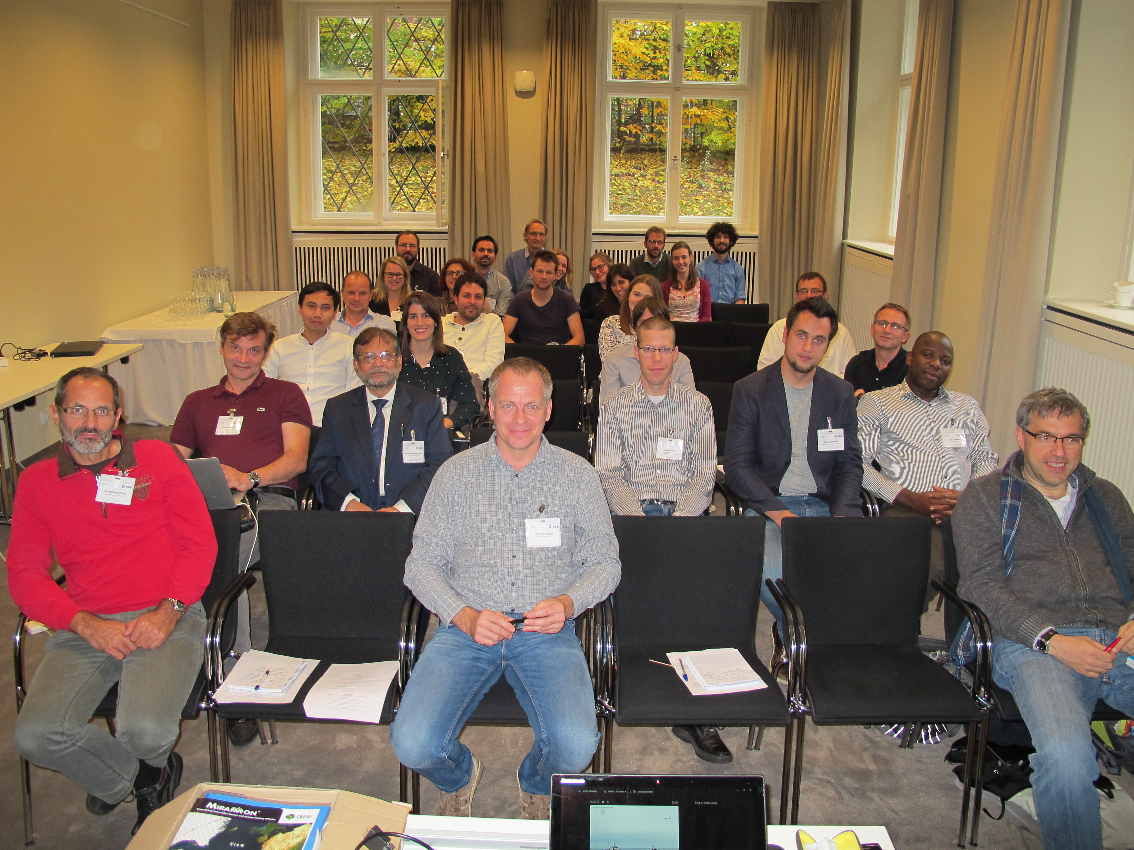
The workshop on atmospheric correction of remote sensing data took place at the Harnack House of the Max-Planck Society in Berlin-Dahlem from 26 Oct. to 28 Oct. 2016. It was co-funded by EUFAR and the European Space Agency and hosted by the Freie Universität Berlin. 30 scientists and experts of remote sensing applications coming from more 10 different European and other international countries attended the workshop and exchanged their knowledge and expertise on this specific topic. The workshop was divided into different parts to cluster the various aspects ranging from radiative transfer models, aircraft and satellite remote sensing applications to their atmospheric correction data processing methods.

A welcome and introduction was given by the EUFAR Expert working group leader on Atmospheric Radiation and Remote Sensing Measurements Thomas Ruhtz (FUB). He explained what difficulties still exist to derive representative information about the status of the atmosphere and showed recent vertical profile measurements of the aerosol optical depth in the vicinity of urban areas like Berlin and Bucharest. The high variability of the vertical and horizontal aerosol distribution in such areas with high anthropogenic sources is one of the main difficulties in characterising the atmosphere. The aim of airborne measurement campaigns is to derive NO2 maps. The retrieval schemes depend strongly on valid information of the atmosphere and the characterisation of the ground albedo.

The first invited speaker Oleg Dubovik (CNRS, France) provided an overview of simultaneous retrieval of surface reflectance and aerosol properties using the GRASP algorithm (Generalised Retrieval of Aerosol and Surface Properties). This open source software package of his GRASP team provides standardised and versatile algorithms, as well as most accurate and complete retrievals.

Alexander Kokhanovski (VITROCISET, Germany) gave a talk about a semi-analytical technique for atmospheric correction of airborne and satellite remote sensing data. He discussed approximate analytical solutions of the radiative transfer equation (RTE). These equations can be used as an alternative to the numerical solution of RTE and the LUT (Look Up Table) approach. He concluded that approximate analytical solutions can be used to speed up aerosol retrieval and atmospheric correction procedures. In addition, they can be used as first guess solutions for more advanced approaches.

The special case of atmospheric correction over water was presented by Tim Smyth (PML, UK). He emphasised the importance of atmospheric corrections to derive water leaving radiances, and secondary products like Chlorophyll concentration, from top of atmosphere radiance. He spoke about issues surrounding vicarious validation of water leaving radiance measurements with moored buoys and ship based in-situ measurements. He finished his presentation with an inter-comparison between different techniques for observing aerosol optical properties, which in themselves are a by-product of ocean colour atmospheric correction schemes.

Carsten Brockmann (Brockmann Consult, Germany) presented the atmospheric correction over land of the satellite Sentinel-2 data of the European Copernicus programme. He explained in detail the processing chain, quality control and correction schemes to derive the surface directional reflectance. Furthermore he gave examples of pixel identification (IDEPIX), correction methods (BRDF, Terrain) and uncertainty estimations.

Mark Warren (PML) presented initial results of four atmospheric correction algorithms using Sentinel-2 data over the Baltic Sea. He showed a qualitative comparison of atmospherically corrected spectra against in-situ reflectance and scatter plots of individual bands. He emphasised the need for improved calibration or pre-processing on the Sentinel-2 data to reduce the detector noise over dark water bodies.

The method presented by Joan-Cristian Padró Garcia (Universitat Autònoma de Barcelona, Spain) consists on fitting a model on the basis of reference reflectance values saved in Pseudo Invariant Areas (PIA) generated from a MODIS reflectance product. A PIA is a polygon (500 m side) that contains a single reference value for each spectral band. This reference corresponds to the surface reflectance of a piece of land radiometrically stable. Each PIA reference value is checked versus the values of the image corrected in the same area in a previous loop simulation. This allows us to exclude PIA located under clouds, their shadows, snow, or those that experimented land cover changes. Moreover, it permits us to correct images of images of the 80's, 90's, 00's and 10's with the same consistency. The user can introduce field data if it is available.

Jan Hanus (CzechGlobe, Czech Republic) presented atmospheric correction procedures for VNIR, SWIR and LWIR spectral range. He described the pre-processing chain established at CzechGlobe for airborne hyperspectral image data and approaches specific for reflective and thermal spectral range.

Dainis Jakovels (Latvian Institute for Environmental Solutions) presented the results from simultaneous airborne and in-situ spectral data acquisition campaigns during summer 2015 in the Gulf of Riga, the Baltic Sea. Different atmospheric correction approaches (empirical line, ATCOR-4 and FLAASH) were tested for retrieval of bottom-of-atmosphere reflectance and chlorophyll-a concentration. The main challenge remains regarding proper estimation of atmospheric path component, but ATCOR-4 corrected reflectance data products showed best performance in retrieval of chlorophyll-a concentration.

The talk presented by Bringfried Pflug (DLR, Germany) gave an overview of the actual implementation of Sen2Cor and recent validation results. Sen2Cor is the processor for Sentinel-2 Level 2A product generation and formatting provided by European Space Agency.

Christina Karakizi (National Technical University of Athens, Greece) presented a quality assessment of Surface Reflectance (SR) products from Sentinel-2 and Landsat-8 sensors. The assessment was undertaken by comparing the datasets with the SR from the high quality products of MODIS sensor. Three atmospherically corrected datasets of the same day were validated. The USGS Landsat-8 SR product using the Landsat Surface Reflectance Code (LaSRC), the Landsat-8 SR data produced using the Satellite Signal in the Solar Spectrum (6S) radiative transfer model and the Sentinel-2 SR product created using the Sen2Cor processor.

Cristiana Bassani (CNR, Italy) talked on the selection effect of the microphysical properties of aerosols on the accuracy of the surface reflectance, land and water, and on other remote sensing products. She demonstrated how sensitivity of the sensor radiance to aerosol optical thickness is influenced by target, aerosol microphysical properties and the environment. She remarked that a misrepresentation of local aerosols can decrease the accuracy of the surface reflectance provided by specific algorithms developed for multi/hyperspectral sensors.

Elena Ruiz Donoso (University of Leipzig, Germany) presented a technique to address the problem of mutually hindered retrievals of cloud and surface properties in areas with prevalent overcast conditions. The method is based in the different spectral absorption features of snow ice and cloud water and allows the simultaneous retrieval of clouds and snow surfaces properties. The applicability of the method was tested on a data set acquired during the VERDI campaign over Canada on May 2012 and the results of a case study were presented.

In summary, the workshop gave a good overview of the topic and field of research with the presentation and discussion on a lot of detailed information. The participating researchers and PhD students were able to collect new ideas and information on how current state-of-the-art atmospheric correction schemes work for airborne and satellite applications and what improvements are possible in future. The general feedback was that such specialised workshops are much more intense and efficient in forming networks and exchanging knowledge and expertise compared to larger conferences. As an outcome of this workshop a special issue in an open access journal was initiated and will be open to all participants and researchers, available here.

All the workshop presentations are available on the EUFAR website on the event page.

For more information, please contact Thomas Ruhtz (thomas.ruhtz@fu-berlin.de).

